**Home Page (First page you see when you go to virtualscope.site)**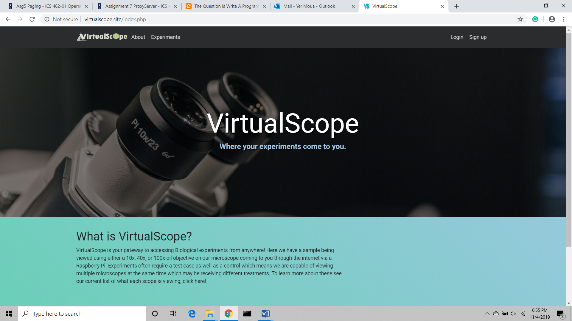

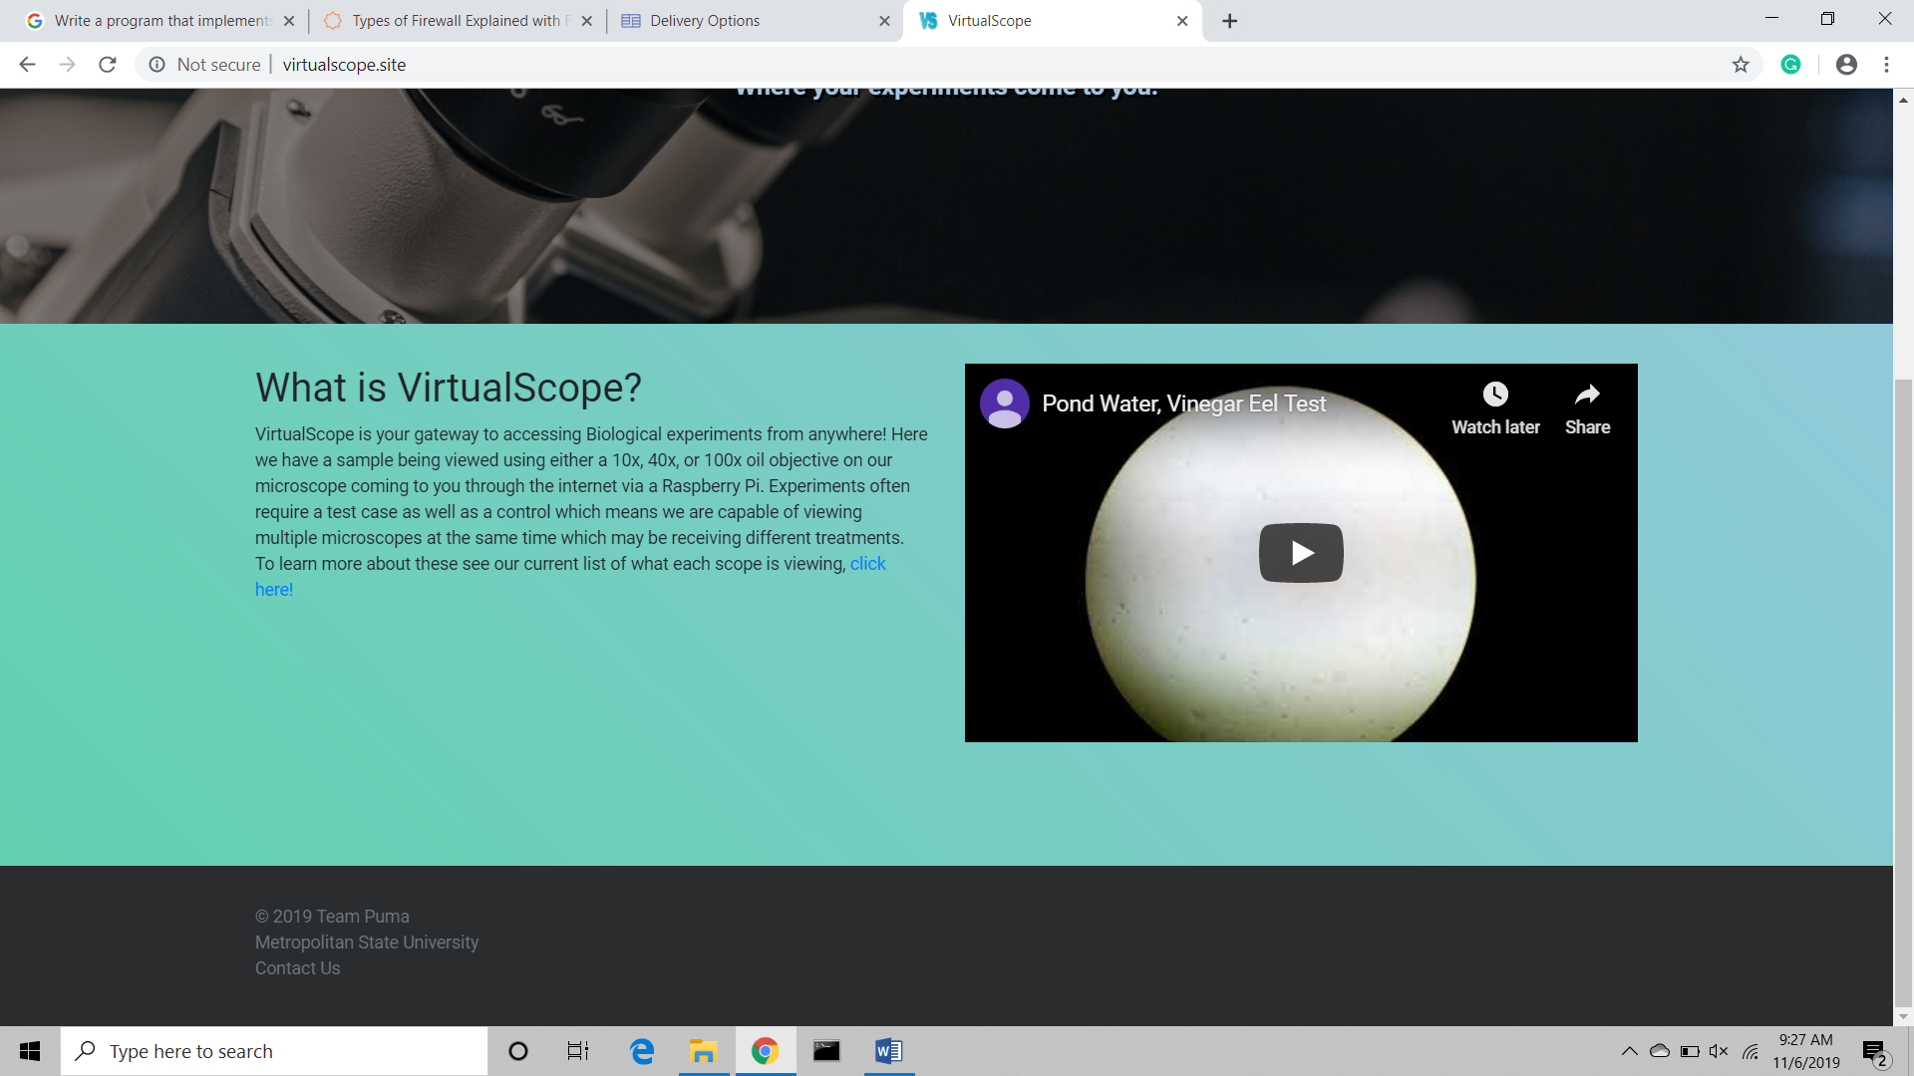

**Signup Page (Sign up for an account)**

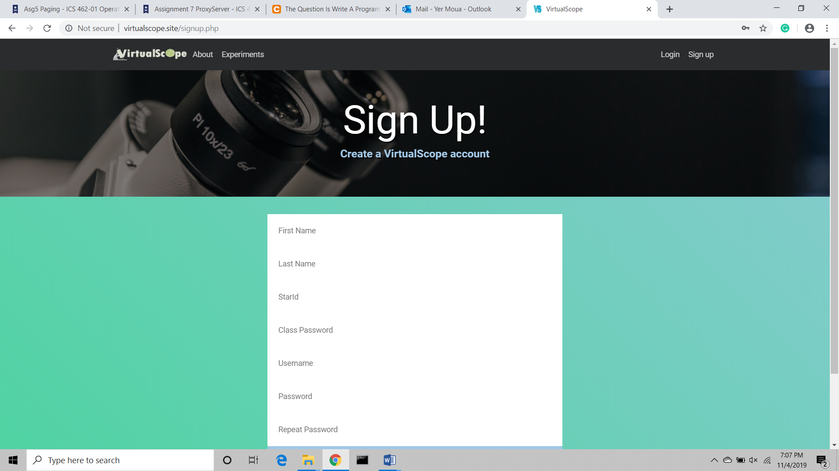 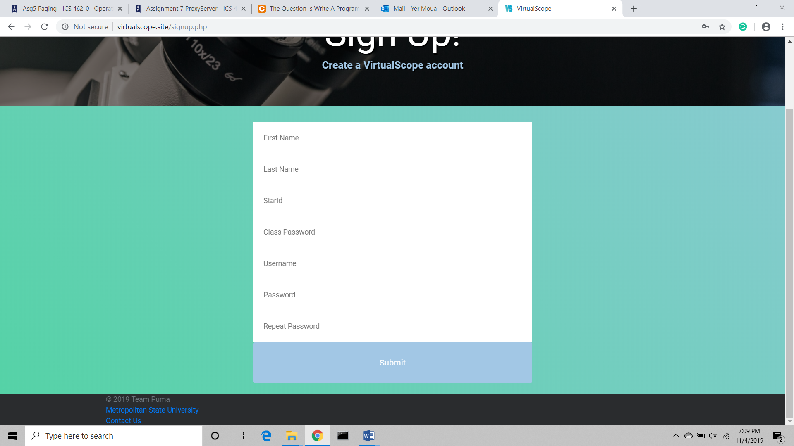

**Login Page (Log in if you have an account)**

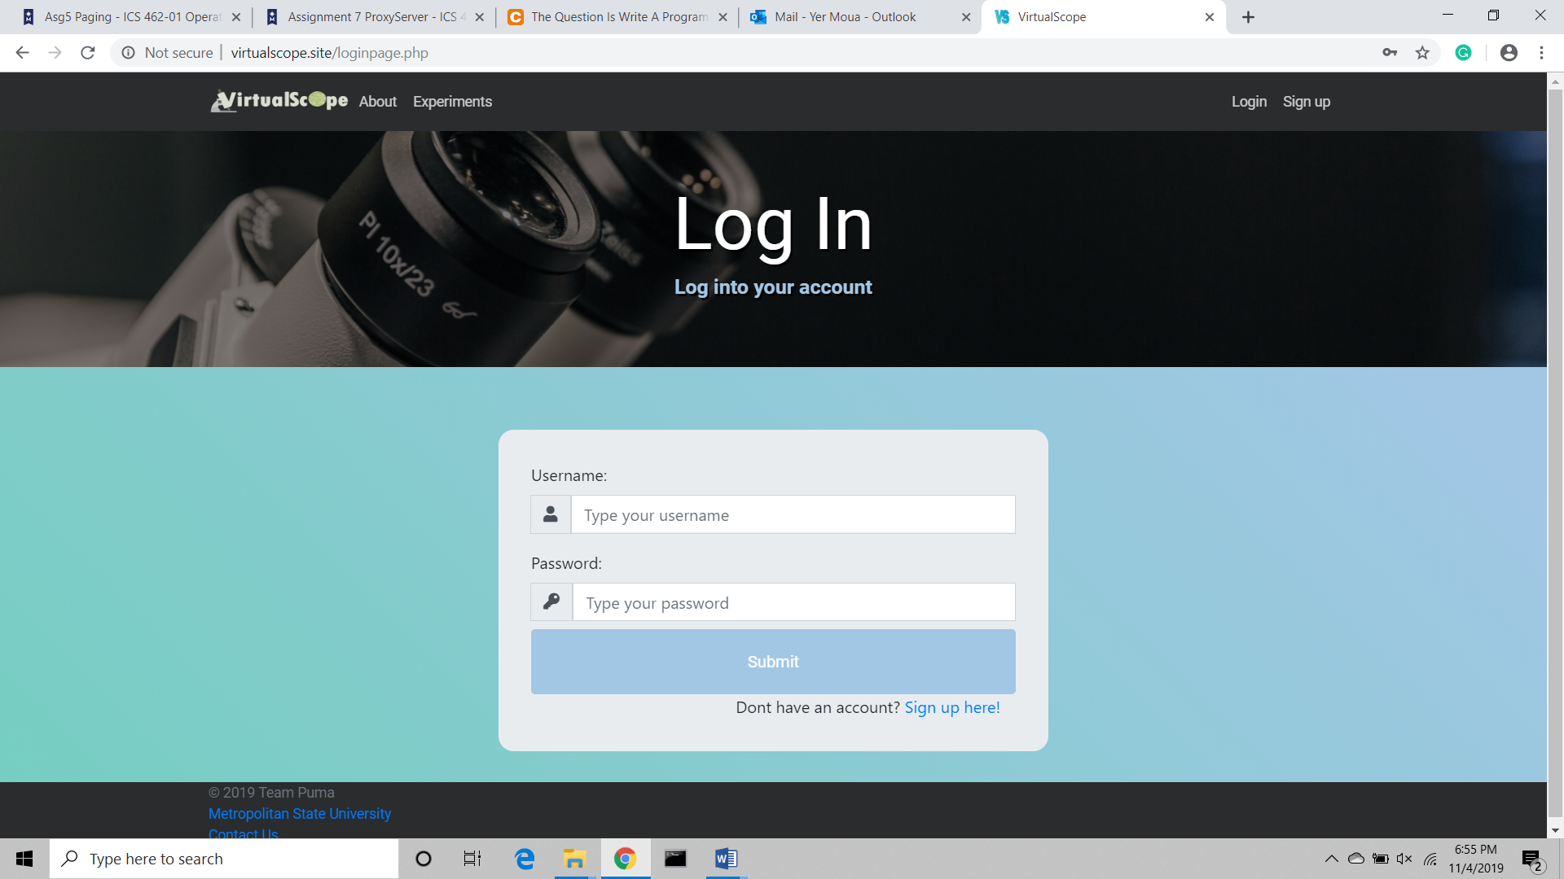

**Experiments Page (After successful login user is directed here)**

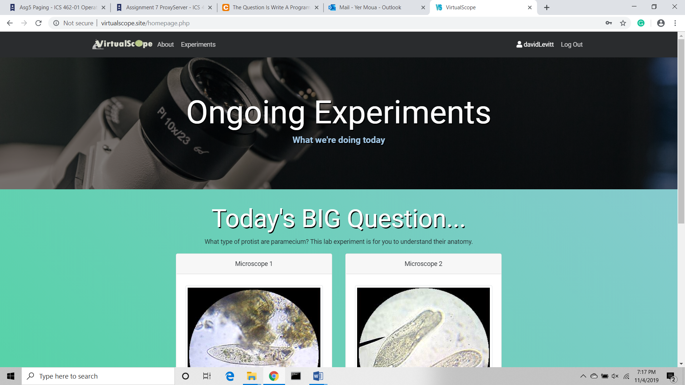

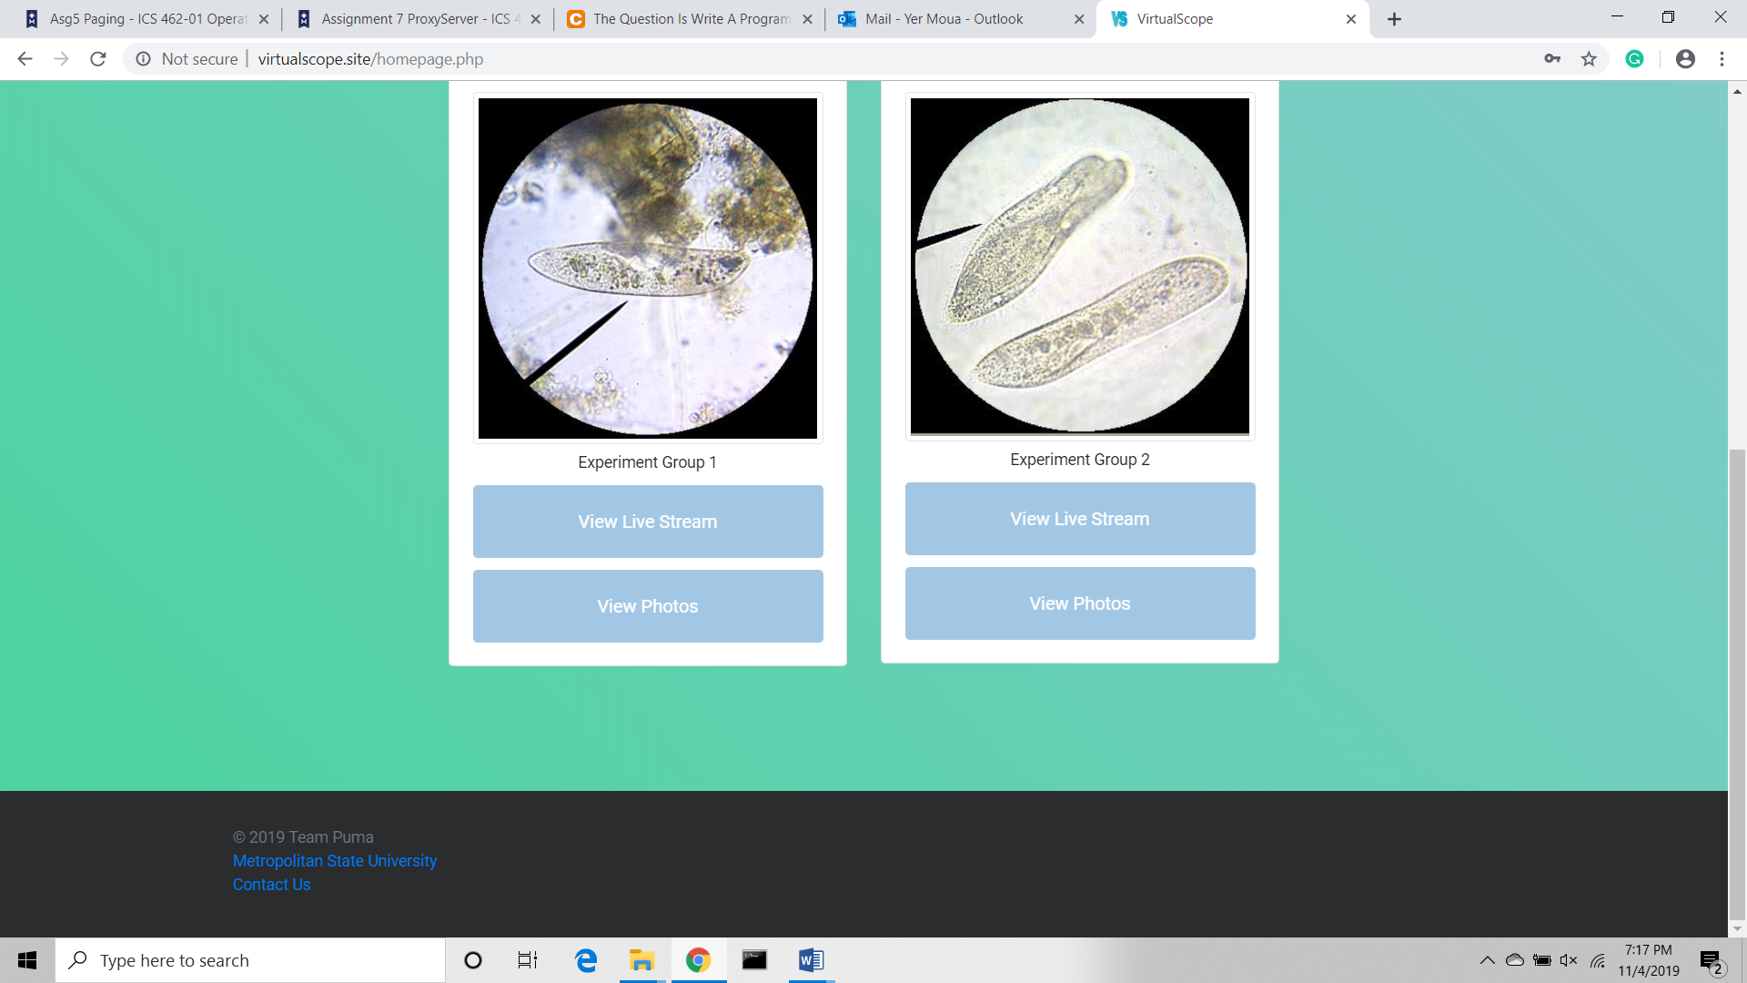

**View LiveStream (Selection of a microscope sends you here)**

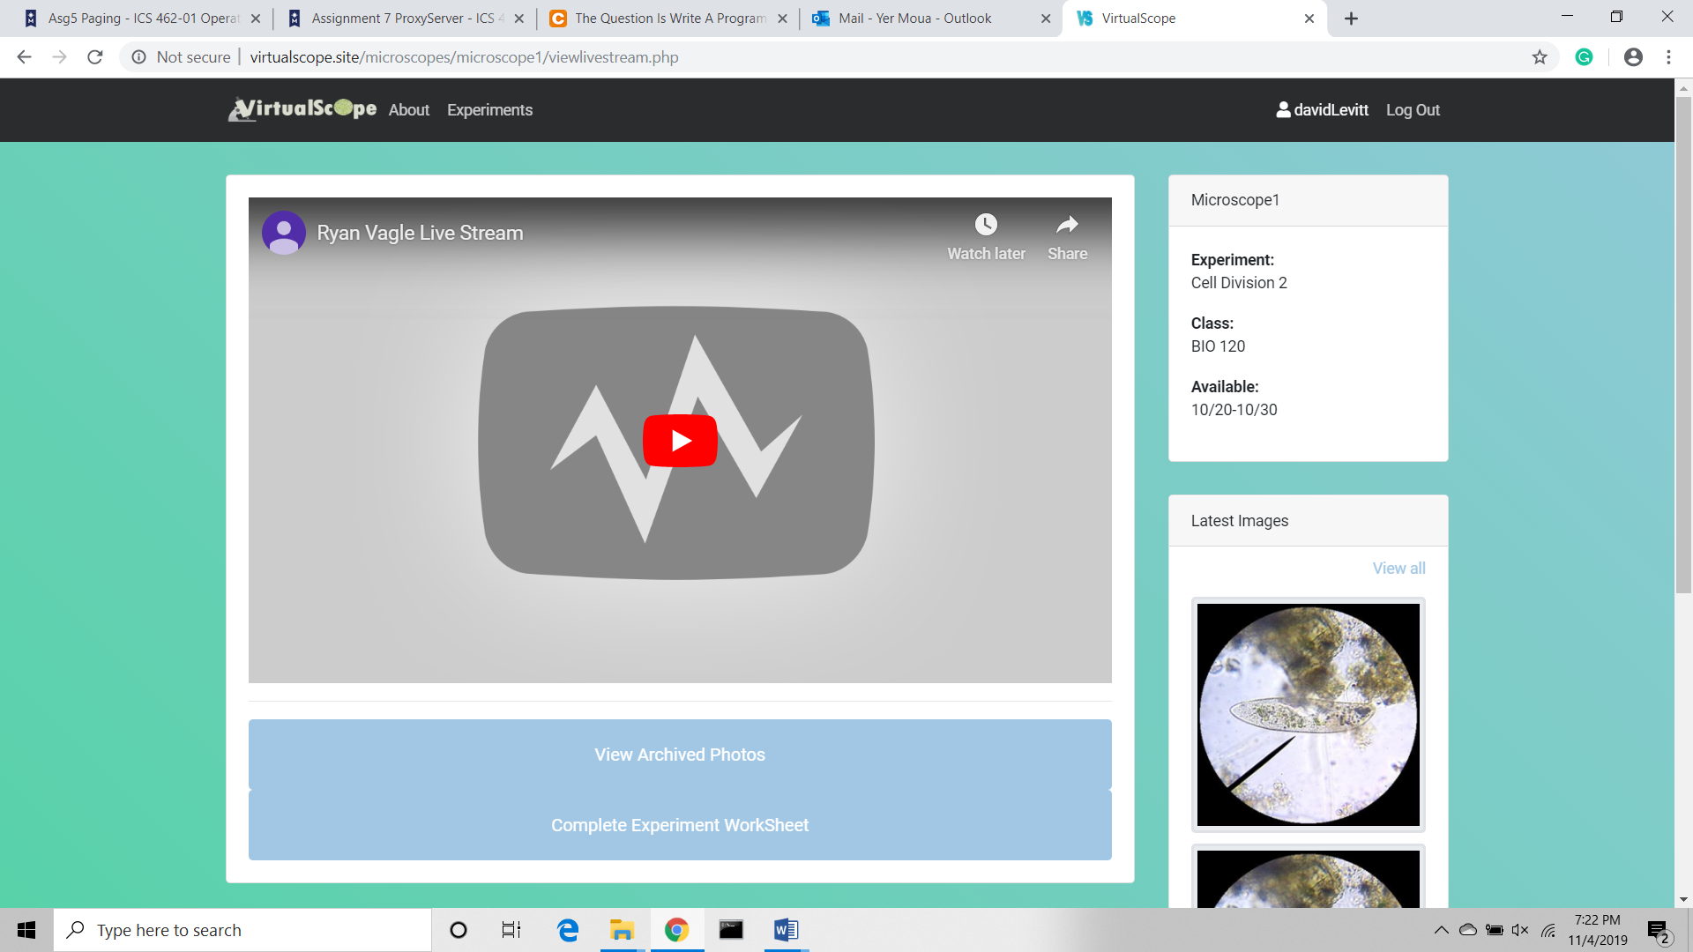

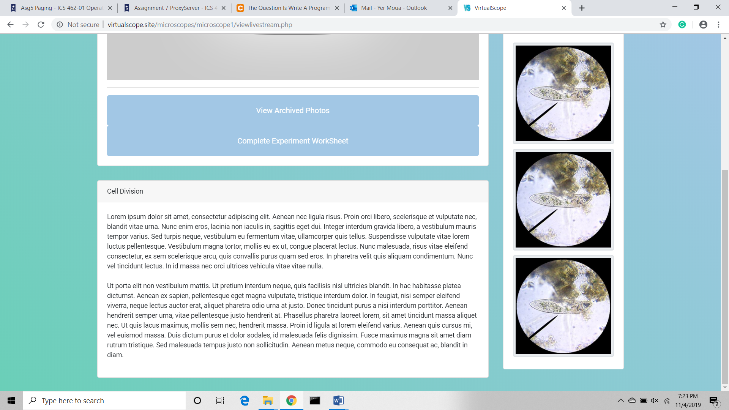

**View Photos**

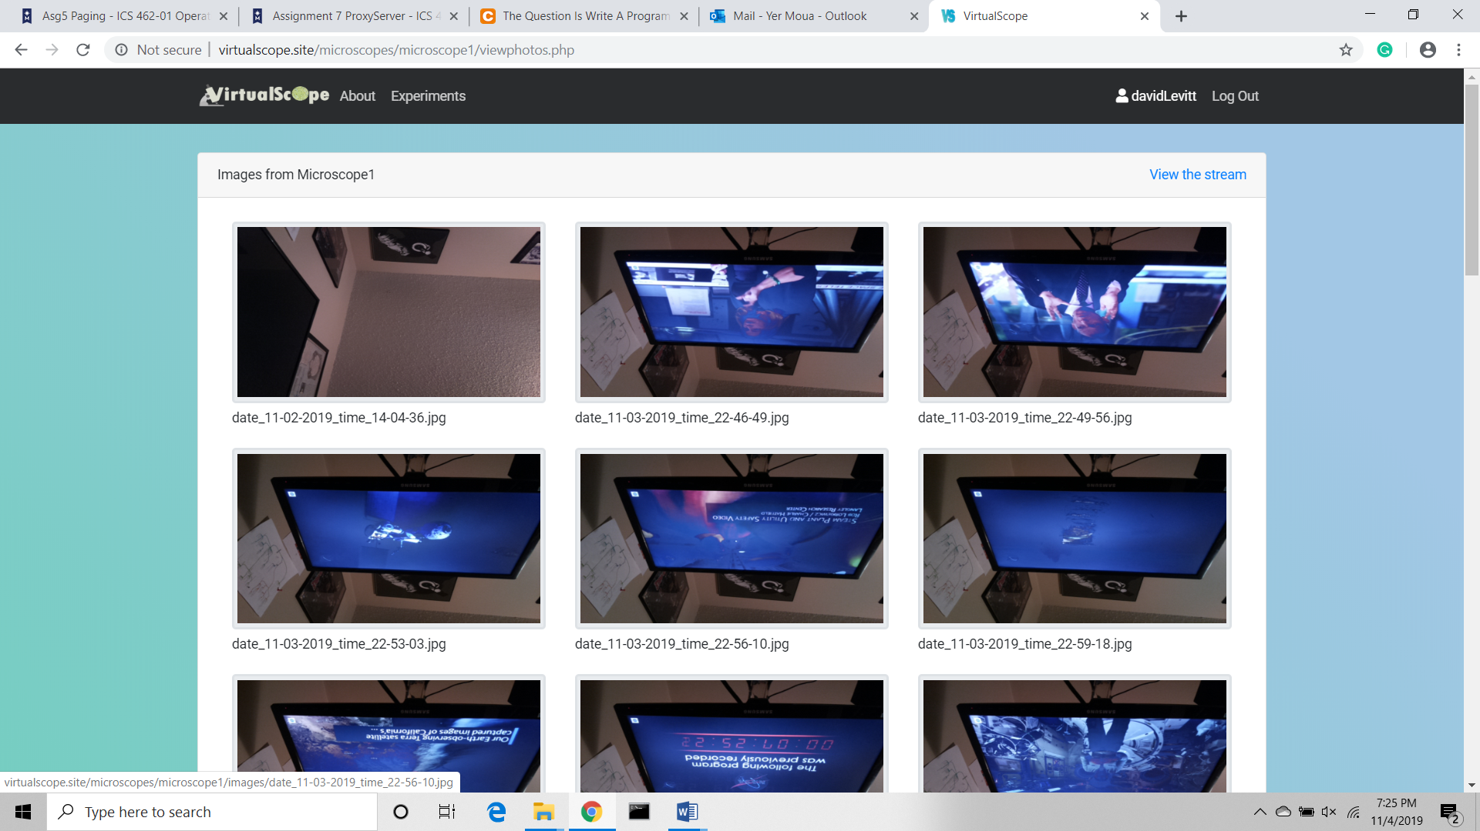

**THE FOLLOWING PAGES ARE ACCESSIBLE BY ADMIN ONLY**

**Experiments Page (With admin access, there is an additional link to the admin panel)**

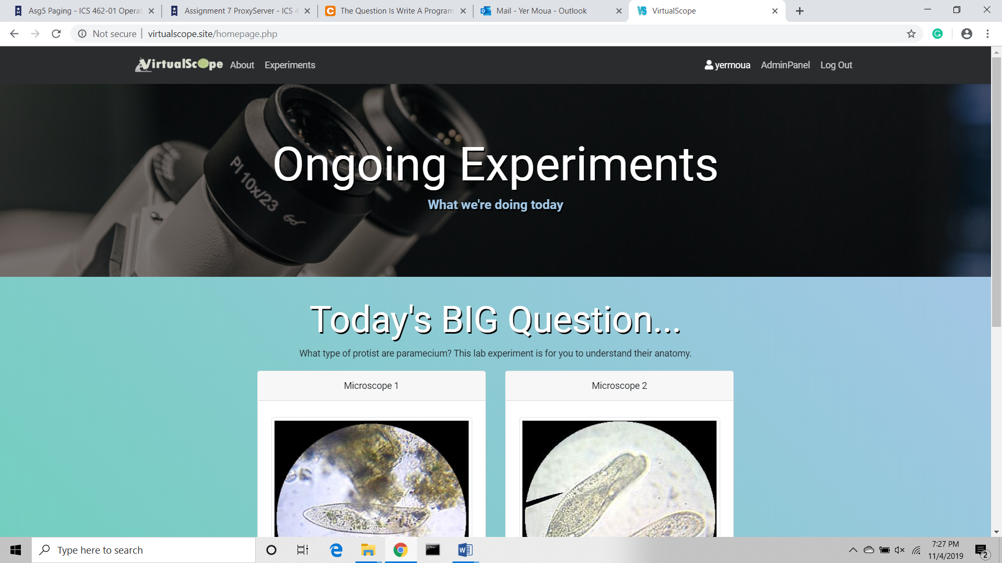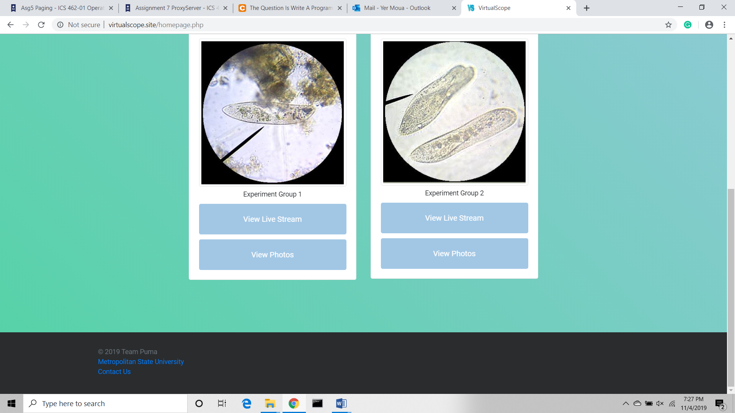

**Admin Panel (Other functions admin can access)**

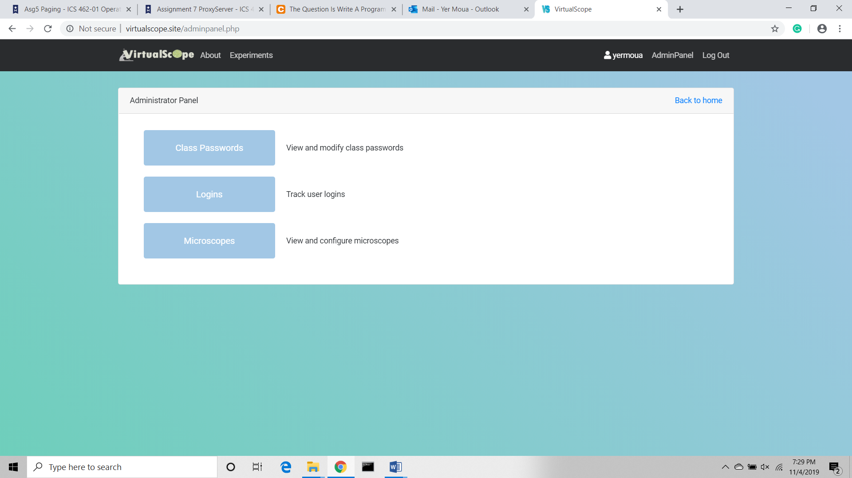

**Class Passwords Page (View, add and/delete class passwords)**



**View logins (View all logins)**

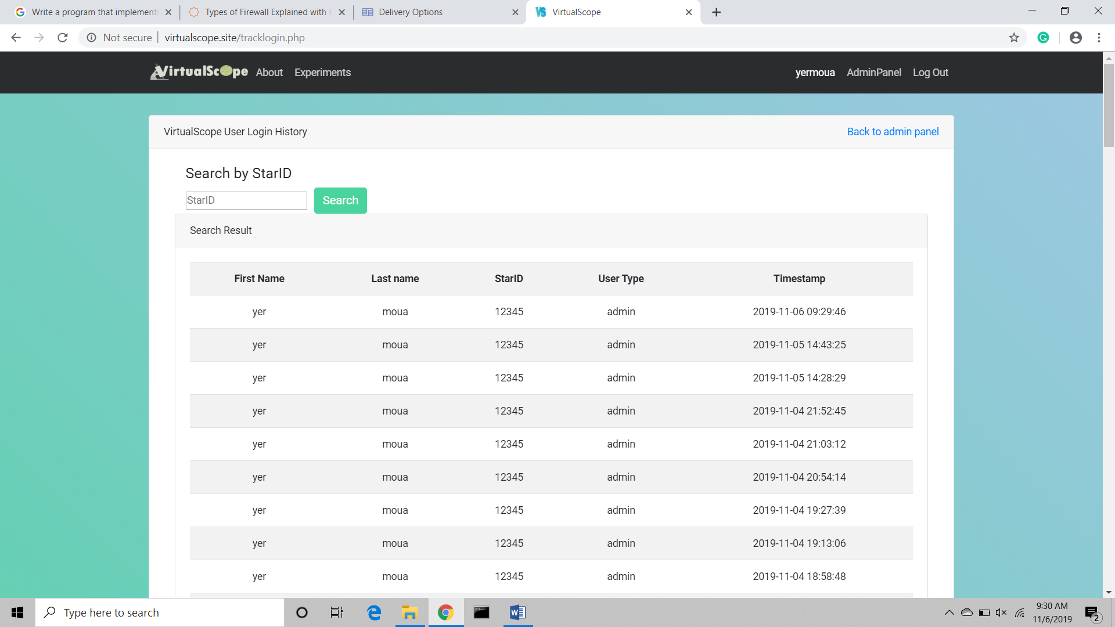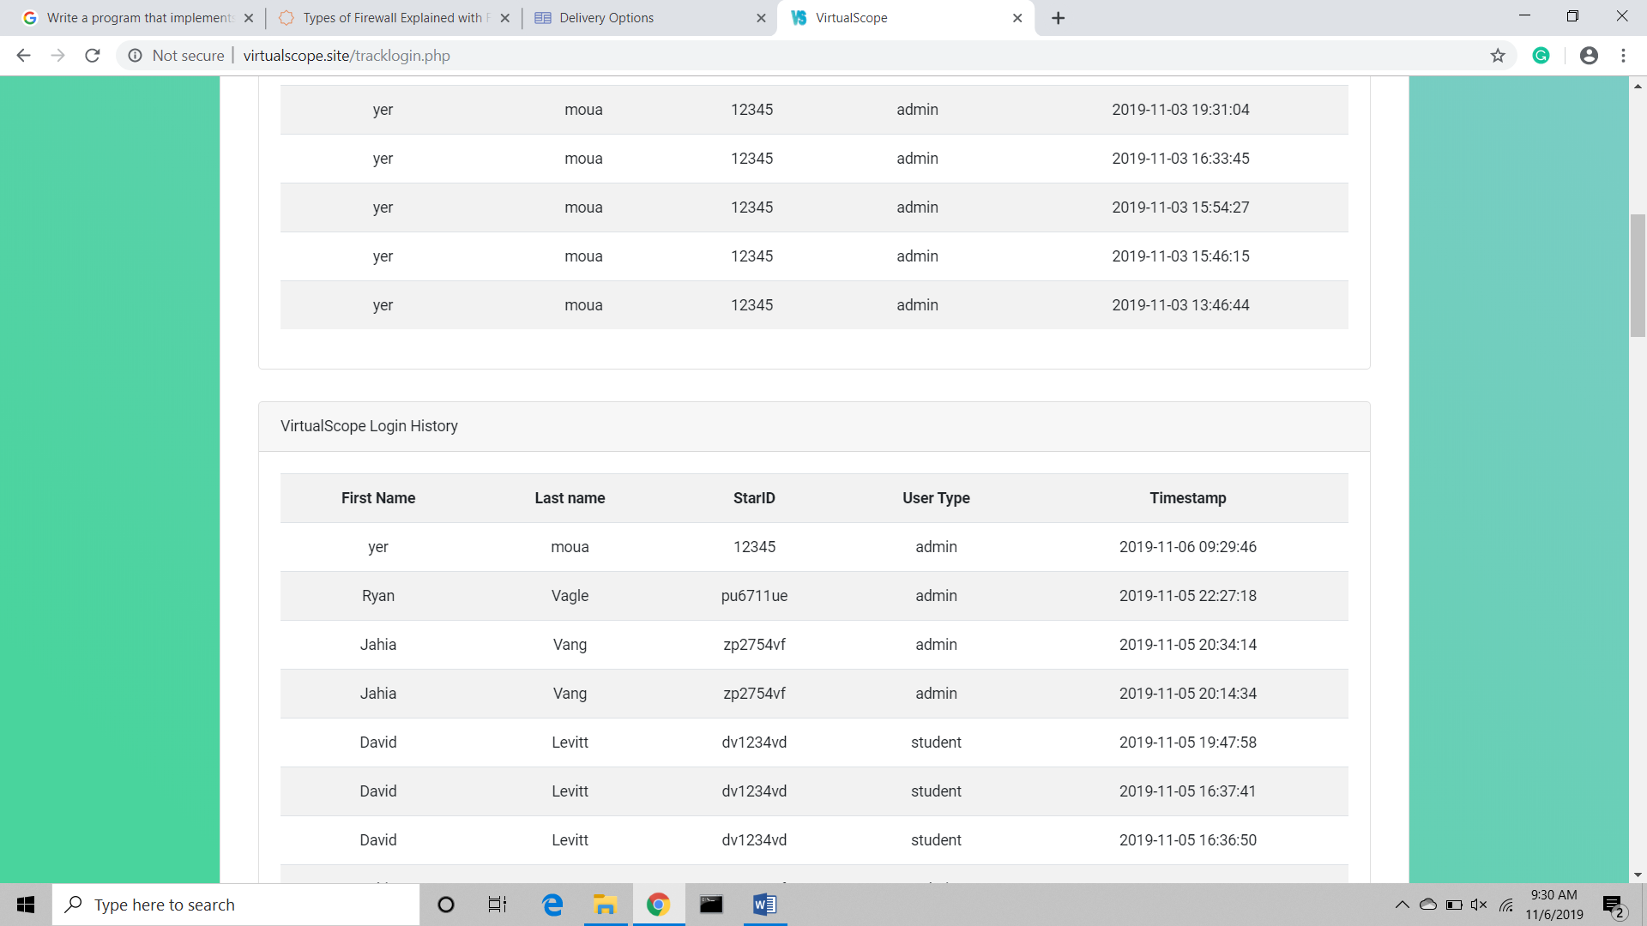

**Microscope Configuration Page (Add or edit a microscope)**

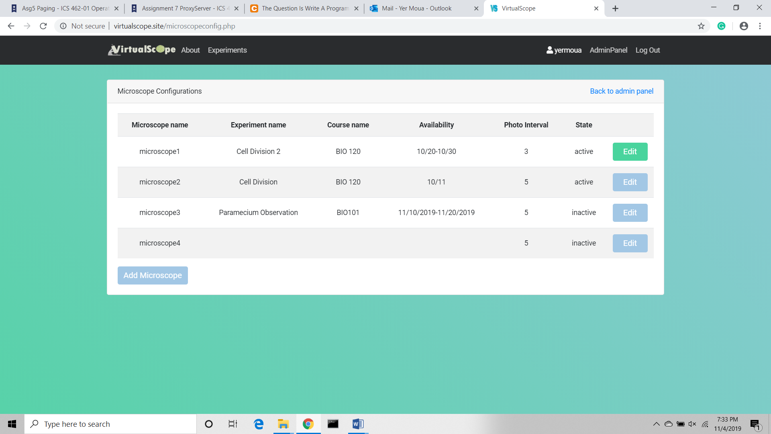

**Edit Microscope (Change fields of microscope)**

